**LAB 2**



**fall 2023**

**Signal Prossacing**

**Submitted by**: **Muhammad Ilyas**

**Registration No**. :21PWCSE2055

**Class Section**: **B**

Submitted to:

**Engr. Sir ABDULLAH HAMID**

**Department of Computer Systems Engineering**

**University of Engineering and Technology, Peshawar**

Task 1: Write two C programs for the analysis of the difference in executable file sizes while using:

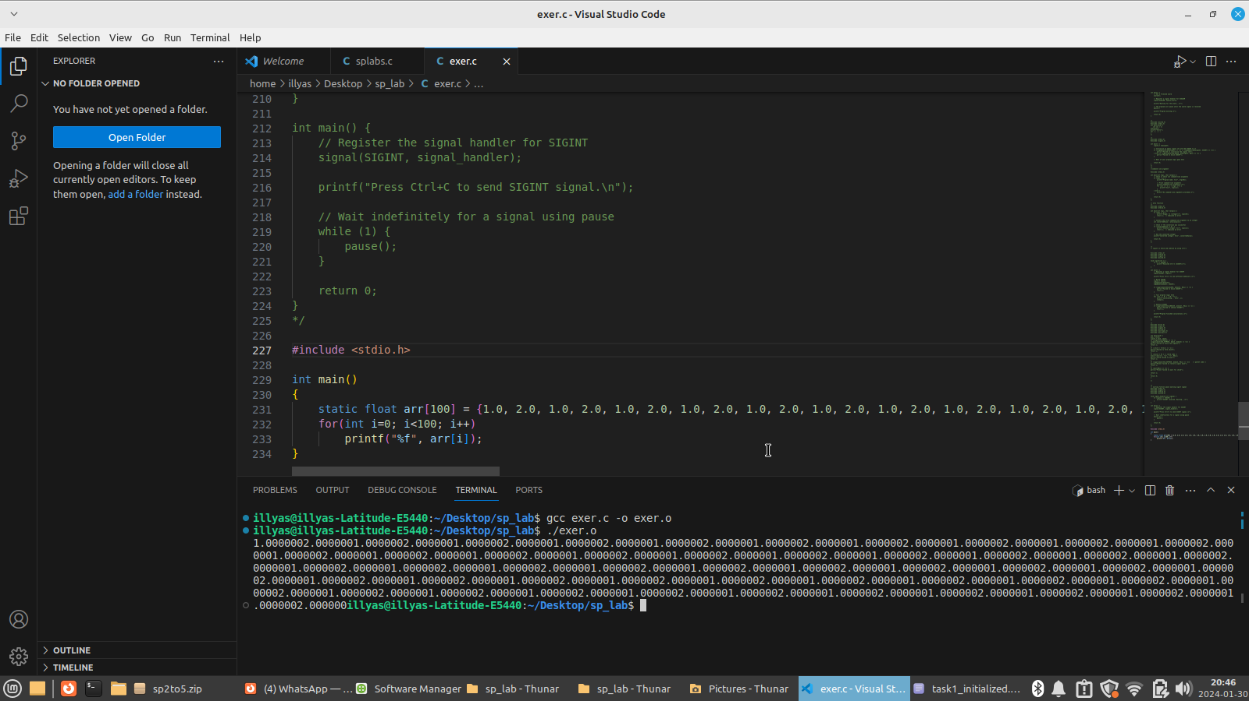

OUTPOT



Task 2: Analyze the return values and error numbers/error stings of wait system call on:

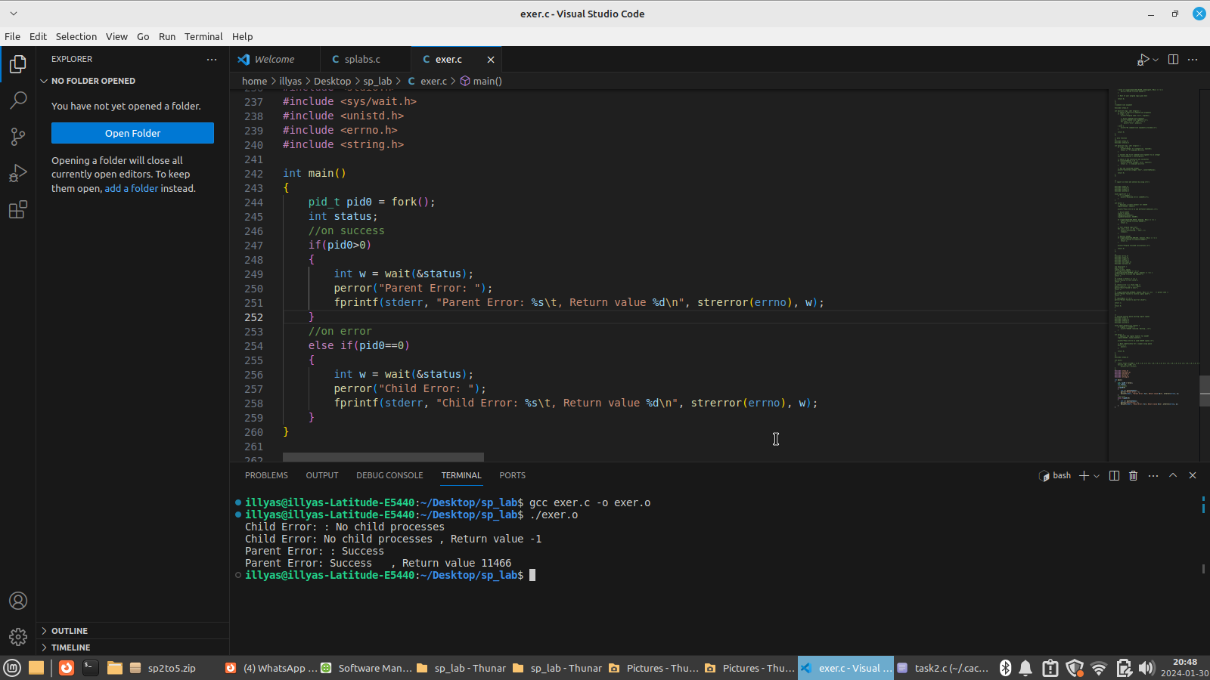

outpot



Task 3: Analyze the return values and error numbers/error stings of close system call on:

